
SOP Title: | eCommerce Shrink Tracking
Document Storage Location: | STACS/Management/ SOP's - Logistics and Warehousing/eComm | Document #: | SEASOP380v100
SOP Originator: | Alie Armstead | Last Edited by: | Valentina Popadic
Effective Date: | 08/01/2020 | Last Edited Date: | 12/11/2023
Other:

- Purpose
  - To monitor, manage, and track the stolen items in the eComm department.

- Scope
  - Coppell eComm – Monitor and resolve missing stock incidents
- Responsibilities
  - 3PL Management shall be responsible for ensuring that all employees receive proper training in the Stock Incidence Report (SIR) reporting procedures
  - SEA Operations team shall be responsible for providing support and resolution for any issues reported by 3PL

- Intructions:
  - Once SEA receives an SIR report for a comfirmed stolen item from the 3PL research of the device movement history begins.
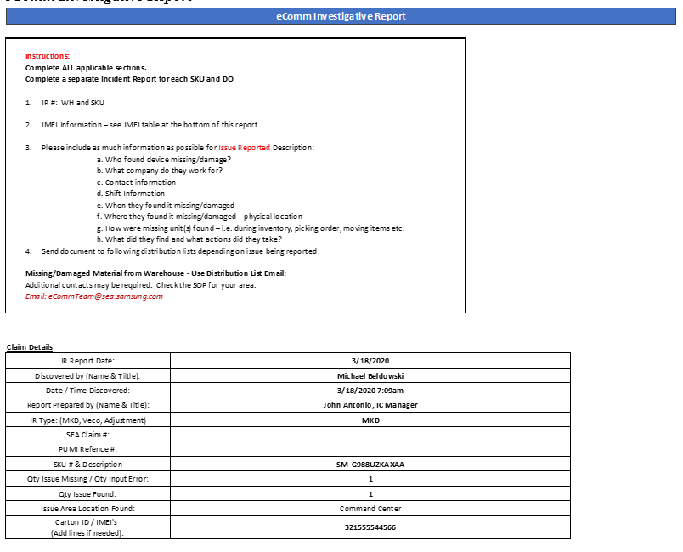

  - Log onto SAP / WMP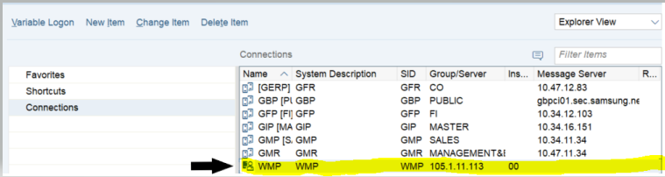

  - To validate and capture SAP movements for specific IMEIs

    - Enter T-Code YWM101090 (EIN/IMEI Master Data List) 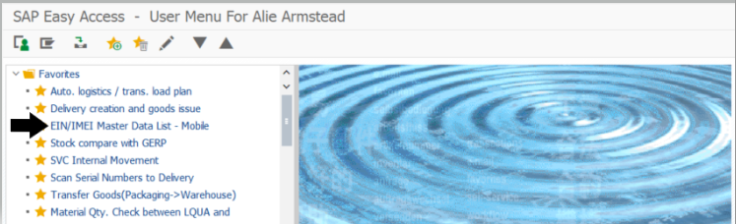

    - “Plant”
      - Input code: S341 as seen below…

    - “Serial Number”
      - Use the first field to look up a singular serial number 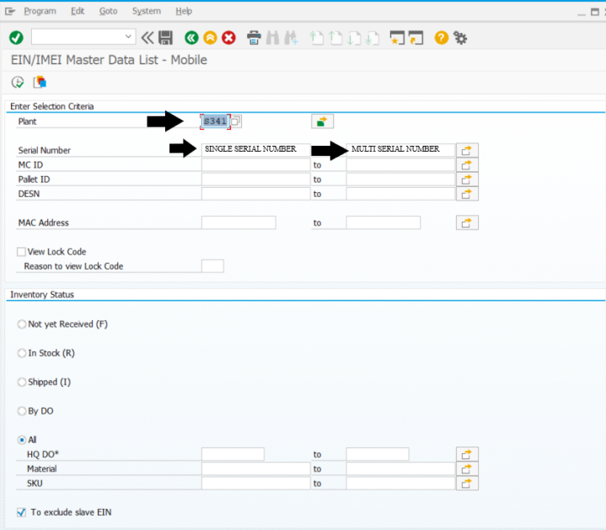

      - Use the second field to look up multiple serial number, then copy and paste your serial numbers in the “Single value” field.
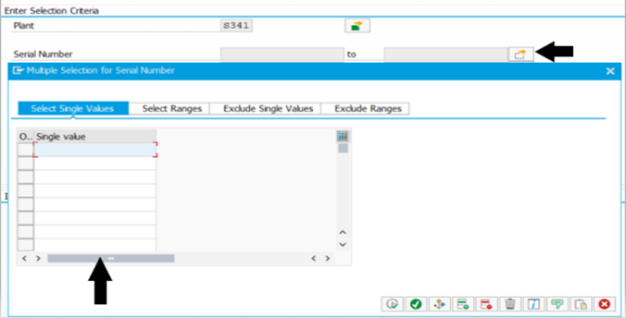

      - Once the IMEI(s) are inputted in the “Serial Number” field, then click the excute icon. 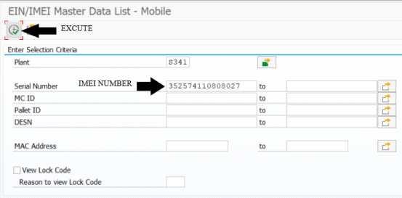
    - Highlight the entire row by clicking the first cell on the row, then select “History Log by Order & Docs”: 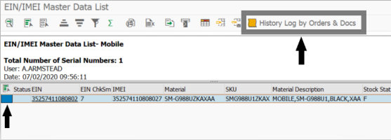

    - The report will look like the below, showing activity for one Serial Number.
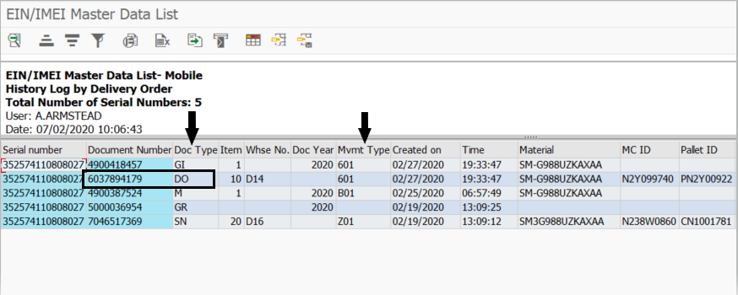
  - Pull up the Shrink Tracker Report
    - SAP Tracker section of the Shrink report:
      - The Shrink Report document is located at the following link:
http://stacs/sites/Logistics/_layouts/15/DocIdRedir.aspx?ID=W52DUE32R37W-21-71
      - Copy from SAP the Document Number, Doc Type and Mvmt Type information to the Shrink Tracker Report, MKD Claims Tab
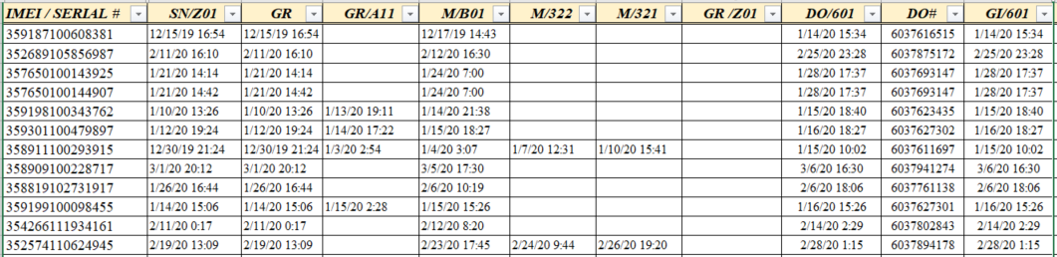

  - To validate and capture Synapse movements for specific IMEIs
    - Go to visibility website https://visibility.ams.geodis.com/visibility/customer and sign in.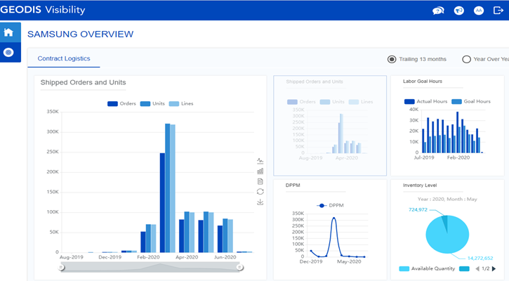

Go to Control Tower (see below) - drop down > Search > Advance Search > Reference Number report.Go to Control Tower (see below) - drop down > Search > Advance Search > Reference Number report. 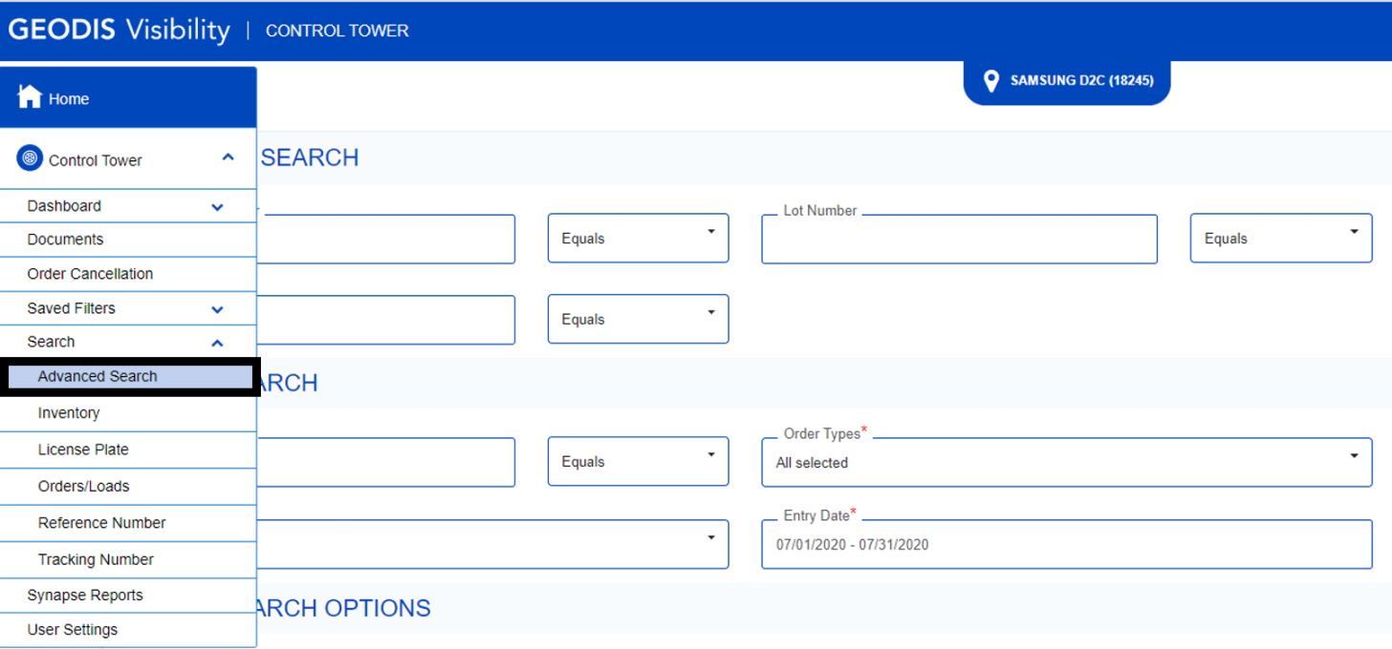

Enter the Document Number from SAP (EIN/EMEI Master Data List) into the “Reference field”, then click the search icon:

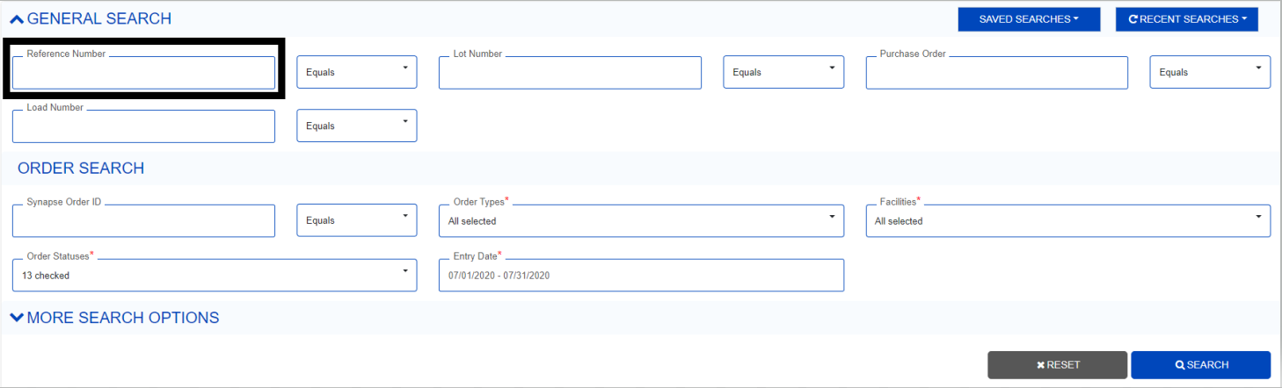

Record the following movements to the Shrink Tracker Report from Geodis Visibility
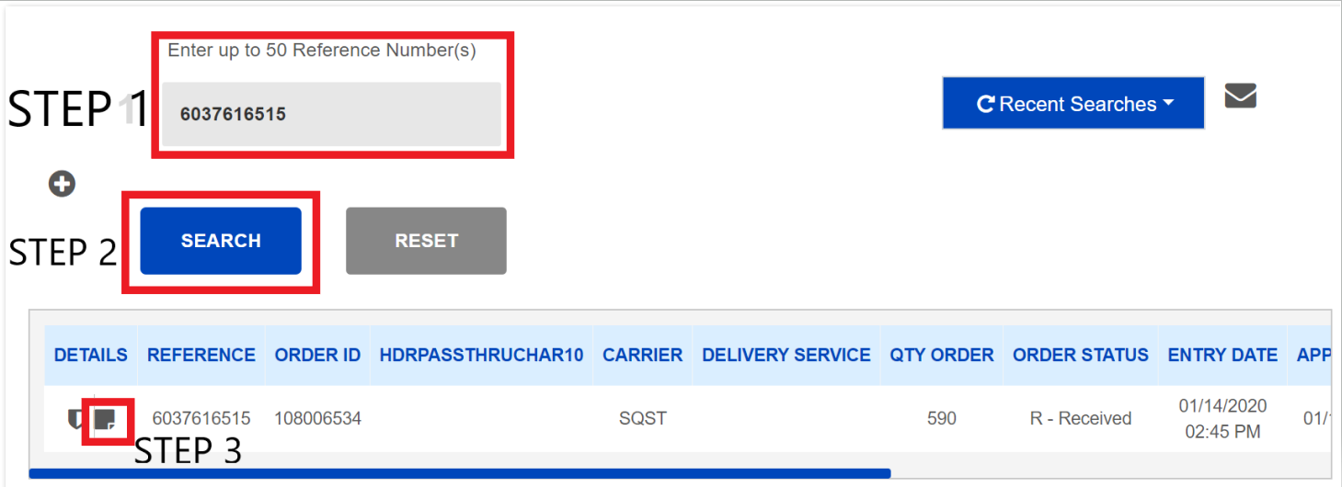
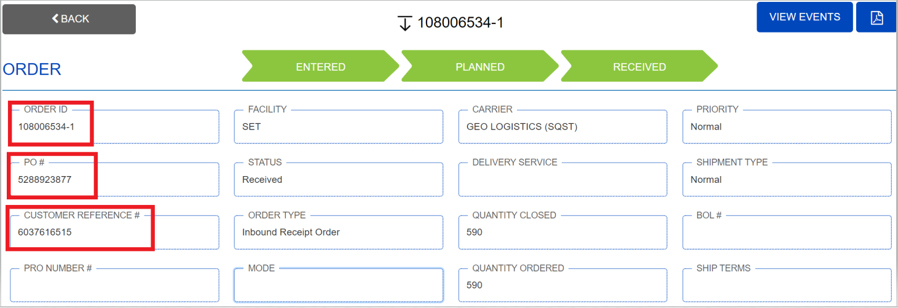
    - Add the movements from above Geodis Visibility report to the Geodis Tracker section on the Shrink report:
      - Information for an IMEI will go onto one (1) line.
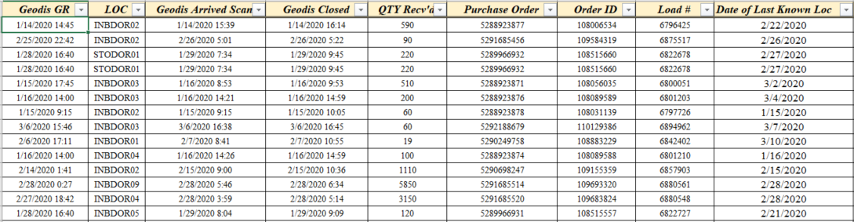

  - Send the update Shrink report to the following groups:
    - eCommTeam@sea.samsung.com
    - IMAuditTeam@sea.samsung.com

  - Once Security Risk & Assessments finish their investigation they will send the findings to the Inventory Management Audit Team and SEA eComm team.
    - SEA eComm team will direct the Inventory Management team on whether a Claim should be submitted.
      - SEA Claims team will submit a Claim once they have all information and permission
    - SEA eComm team will be responsible for writing PUMIs and getting management approval
    - SEA eComm team will be responsible for making inventory adjustments once the PUMIs are approved
      - SEA eComm team will direct Geodis to make their transactions in Synapse
      - SEA eComm team will make the adjustments in GMP and WMP

